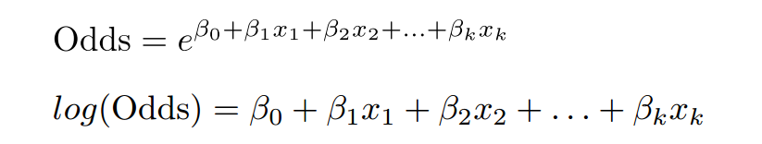
This is the logit:

We know that b0 + b1x1 + b2x2 = -1

So the logit is -1

...and the odds is exp(1) or 0.3678794

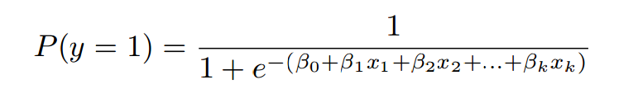
or 1 / (1 + exp(1) = .2689414

This is the confusion matrix:

Large threshold means hard to predict 1. We make more errors predicting 0 when it's actually 1 (Few Fps; Many FNs). If we do predict 1, we are confident
Small threshold means easy to predict 1. We make more errors predicting 1 when it's actually 0 (many Fps; Few Fns). If we do predict 1, we are not sure.
TP = HIT
TN = CR
FN = Miss
FP = FA

Sensitivity = True positive Rate = TP/ (TP + FN): Percent of trues we classify correctly = HIT/(HIT+Miss)

Specificity = True negative Rate = TN/ (TN + FP): Percent of falses we classify correctly = CR/(CR + FA)

A model with a higher threshold will have a lower sensitivity
and a higher specificity.
A model with a lower threshold will have a higher sensitivity
and a lower specificity.
ROC Curve plots sensitivity on Y axis and 1-specificity (False positive rate) on the X Axis.

The AUC of a model has the following nice interpretation: given a random patient who actually received poor care, and a random patient who actually received good care, the AUC is the perecentage of time that our model will classify which is which correctly.

Normally put between 50 and 80 percent of the data in the training set. Need less when the sample is bigger.

Accuracy of prediction = (TP + TN) / sample size.

Accuracy of baseline model is 1-mean of the binary DV. (e.g. to always predict 0)

NB: The prediction model may not have greater accuracy than the baseline model, but it could still be useful if the goal is to minimize (say) false positives. Changing the threshold might also be useful, even if doing so doesn't change the overall accuracy.

